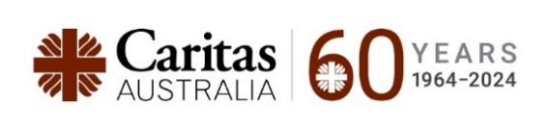
Parish Bulletins throughout December
Lebanon Crisis Appeal
The escalating conflict between Israel and Hezbollah has pushed Lebanon into severe turmoil, with tragic consequences that have spread from Southern Lebanon to the entire nation. The situation is dire: over 3,000 lives have been lost, more than 13,000 people injured, and critical infrastructure has been destroyed.
In response to a heartfelt plea for assistance by Bishop Tarabay and Bishop Rabbat, the Australian Catholic Bishops Conference in partnership with Catholic Religious Australia, Caritas Australia and Caritas Lebanon, has launched the Lebanon Appeal.
This appeal aims to provide essential humanitarian aid to our brothers and sisters suffering in Lebanon, especially those who are displaced and without homes or shelter.
Donate today: www.caritas.org.au/lebanondonate
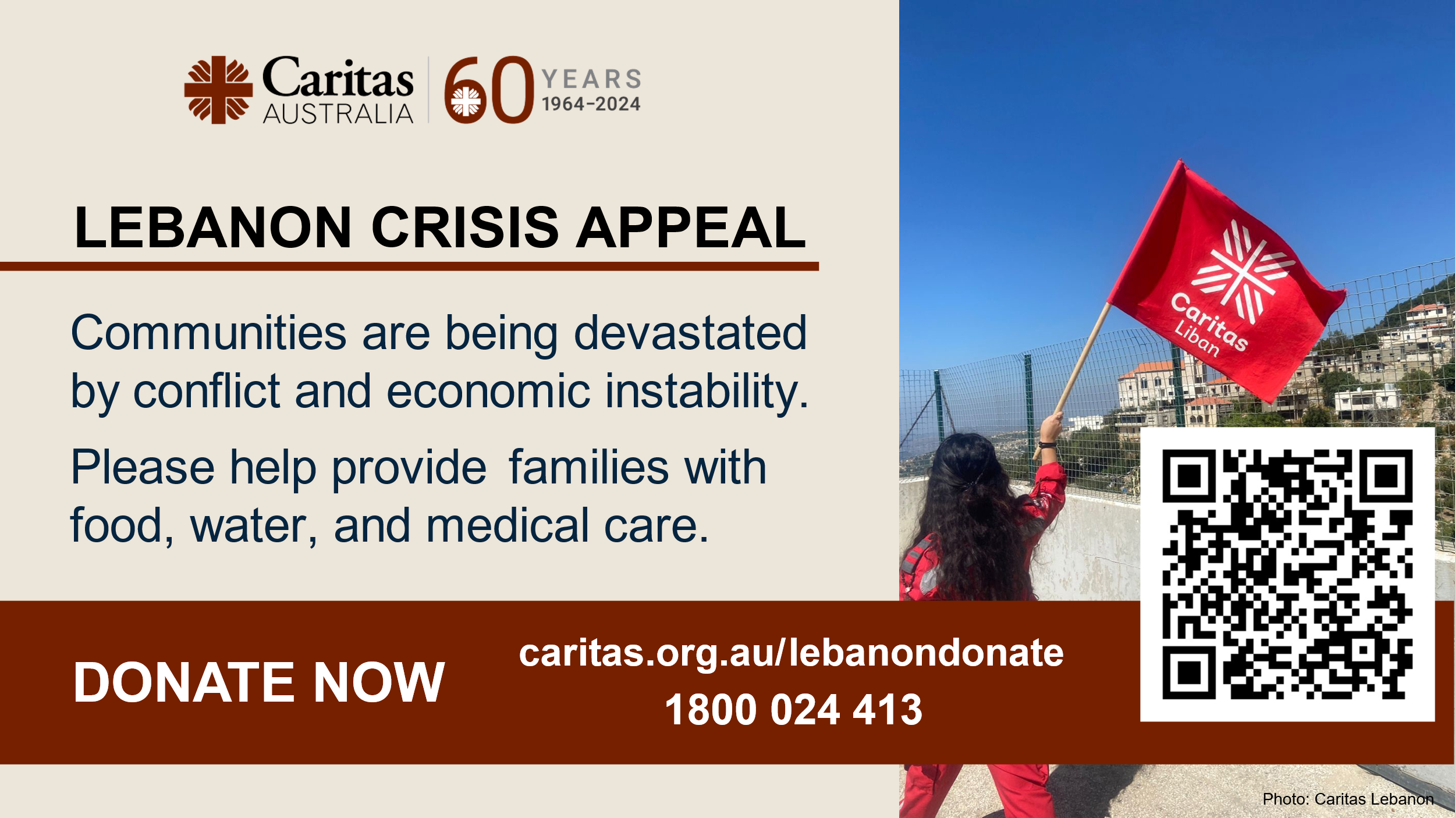 | 

Christmas Appeal
This Christmas, families like Sakhina’s are facing the devastating risk of disease due to a severe lack of clean water and proper sanitation in the world’s largest refugee camp.
But with your support, we can bring hope to these families. As part of the second-largest humanitarian network in the world, Caritas Australia and our partner Caritas Bangladesh are on the ground, ready to act. Together, we can improve access to clean water, provide better sanitation, and help reduce the spread of deadly waterborne diseases this Christmas.
Donate today at caritas.org.au/christmas
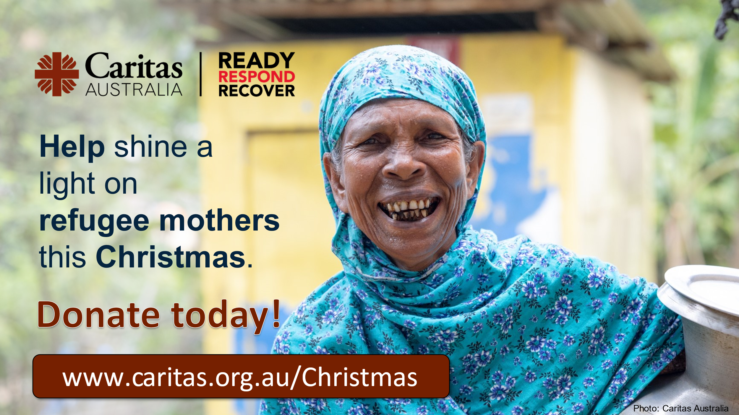 | 

